Reclaim 30 Contributions Towards Reducing Carbon Footprint And Sustainability
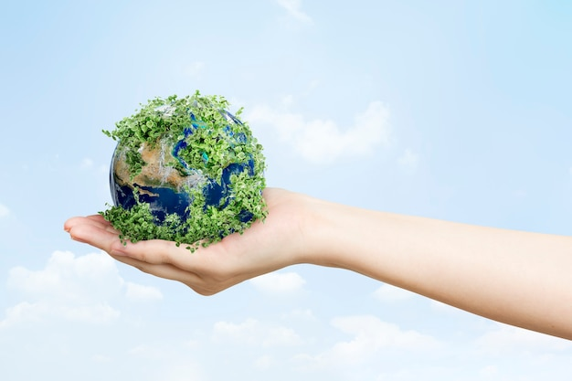

Executive Summary

Plastic pollution is one of the biggest contributors to global warming and carbon emissions. The industrial sector has been largely responsible for producing plastics, leading to many environmental problems stemming from plastic waste. In order to reduce their carbon footprint, industries have now started to take proactive steps towards educating consumers on the importance of sustainability and reducing plastic waste.

In line with this, Reclaim 30 is an initiative that works towards reducing global emissions through sustainable practices in respective industries.

This project has facilitated efforts between diverse sectors, investing resources into making production more efficient while minimising negative impacts on our environment. Through this project, we hope to develop green technologies to mitigate any further potential damage caused by human activities.

Climate Change: Rising Carbon Footprint Due To Single-Use Plastic Waste

Plastics have flooded every aspect of modern life since their mass manufacture began in the 1950s. However, they really threaten our environment because they cannot be broken down naturally. Single-use plastics can take anywhere from 100 to 500 years to degrade, making them a major contributor to landfill and ocean pollution and greenhouse gas (GHG) emissions.

The call to ban single-use plastics has only increased in volume since the premiere of Blue Planet II, Sir David Attenborough's groundbreaking television series. Furthermore, many people didn't appreciate the value of disposable plastic until the COVID-19 pandemic hit.

Face masks, syringes, and hand sanitiser bottles are all examples of single-use plastics that were once reviled but have now been shown to save lives. However, there is no denying that every effort should be made to reduce the prevalence of such plastics.

On the other hand, single-use plastic bag-encrusted dead whales have recently garnered international attention. Many cities are inundated with plastic trash on the ground and microplastics in the air. This is a direct result of the widespread usage of single-use plastics.

It's easy to overlook the significant role that manufacturing single-use plastics plays in contributing to problems like climate change. Single-use plastics have a huge carbon impact, but so do many practical alternatives. This is why it's tough to settle on a sustainable option.

Consequently, businesses that want to reduce their reliance on single-use plastic should proceed cautiously when choosing alternatives. Trash management professionals can agree on one thing: the globe produces and consumes far too much single-use plastic trash. And there's a record-high output of it every year.

The Financial Impact Of Plastic Packaging Tax

According to a 2014 E.P.A. estimate, Americans produce about 258 million tonnes of waste ^{[1]} annually, of which 169 million tonnes are sent to landfills and incinerators. Hence, FIBCs, or flexible intermediate bulk containers, are essential in manufacturing. These bags made from woven polypropylene (PP) have quickly replaced all other options for shipping, storing, and carrying bulk quantities of dry products. Grain, powder, pellets, flakes, granules, flakes, and a wide variety of other material forms can all be stored in FIBCs.

They are a great option for saving money on shipping because they are smaller and lighter than standard containers while providing the same level of protection from the elements and potential damage. These bags have numerous applications in the chemical, culinary, and pharmaceutical industries.

How Emmbi Is Creating A Circular Economy For Plastics

Emmbi, a world pioneer in polymer processing, uses its proprietary Reclaim30 compatibiliser-based technique to guarantee that its FIBC bags contain 30%+ reclaimed PP.

The Reclaim30 from Emmbi is the first and only recycled FIBC bag to receive certification from Labordata. It comes in three sizes (1000 kg, 1 250 kg, and 1500 kg) and has a safety factor of 5:1.

Emmbi's cutting-edge infrastructure includes an in-house reprocessing facility, which can manufacture over 500 MT per month, guaranteeing regular and time-bound supply. Emmbi has formed alliances with industry-leading processors for future shipments.

In addition, you can claim PPT exemptions with the help of the regulatory paperwork included with Emmbi's Reclaim30 FIBC bags and the assurance of full traceability from start to finish.

Making A Case For FIBCs

The ordinary bags and boxes used for bulk packaging are usually hazardous to the contents. All phases of their creation and disposal result in the release of toxic gases. Plus, cardboard or corrugated boxes are frequently discarded without being broken down first. As time passes, these become contaminated and a haven for bacteria and diseases.

With regard to environmental friendliness, FIBCs score quite high. You may recycle them and use them over and over again. They can also be easily repurposed even if recycling is no longer an option.

Hence, Flexible Intermediate Bulk Containers (FIBCs) are a popular and sustainable alternative to single-use plastics. FIBCs are made of a single homo polymer, a type of plastic with the same molecular structure throughout its entire form. This makes them highly durable, allowing them to be reused multiple times before being recycled into new materials. They can also be used for the safe storage and transport of goods.

The use of FIBCs allows businesses to reduce their carbon footprint while still being able to effectively move goods from one place to another. Additionally, they help manufacturers reduce packaging costs since they can hold larger volumes than traditional packaging options like cardboard boxes or plastic bags. FIBCs have proven themselves to be effective solutions when it comes to reducing waste and promoting sustainability in the long run.

How Emmbi's Reclaim30 Contributes To Carbon Footprint Reduction For A Better Tomorrow

The phrases "green living" and "eco-friendly" have become ubiquitous recently, appearing on everything from infomercials and talk shows to supermarket shelves and product labels. An item is considered eco-friendly if it is not damaging to the environment, as implied by the term itself. Resource-saving goods are the most common example of this trend. Eco-friendly goods, said simply, lessen the adverse effects of pollution on the environment.

Businesses concerned with environmental sustainability may give extra thought to the materials used to create their goods and their packaging. This function is typically filled by recycled polypropylene in the industrial packaging sector.

As it stands, the market value of recycled PP is less than the value of virgin PP. Therefore, manufacturers are hesitant to include recovered PP in their goods. Emmbi's Reclaim30 technology, built on a compatibiliser, guarantees an average of 30% recycled PP in the FIBC.

Emmbi's Reclaim30 FIBCs feature the first compatibiliser-based recycled PP, which has performance metrics nearly identical to those of virgin PP. Reclaim30, based on Emmbi's unique technology, is usable in every situation that calls for recycled PP and is compatible with all virgin PP grades.

Lastly, Emmbi has been a pioneer in the movement toward a polypropylene circular economy with their Reclaim30 programme. Visit https://emmbi.com/reclaim30/ or email at sales.export@emmbi.com to learn more about Emmbi's Reclaim30 FIBCs.

Ref used:

- https://www.epa.gov/sites/default/files/2016-11/documents/advncng_smm_infogrphc-2014-sm.pdf

- Anchor Image link: https://www.freepik.com/free-photo/sustainable-living-environmentalist-hand-holding-green-earth_15604456.htm#query=sustainability&position=5&from_view=search&track=sph

